**GITHUB**

GitHub is a web-based git repository hosting service. It offers all of the distributed version control and source code management functionality of git as well as adding its own features. It provides access control and several collaboration features such as bug tracking, feature requests, task management, and wikis for every project.

**Alpha users getting access to Github in organization**:-

Members of the NM organization can only use the nm github, where users need to request the group to add into AG-GITHUB-USERS. For creating a new repository under the nm organization. Once you logged in

A home page of NM organization displays.

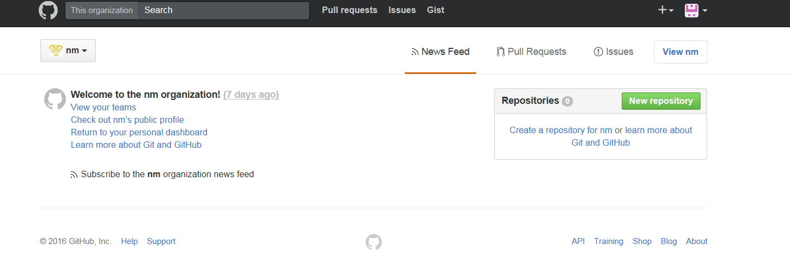

1. In the top right corner of page, click your profile photo, then click: **Your profile**.

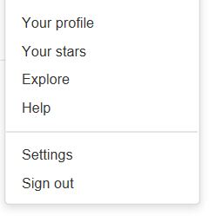

2. On the left side of your profile page, under "Organizations", click the icon of NM organization logo.



1. Here, you can click and add the new project repositories under nm organization and for the personal repositories are added under the AD login space.

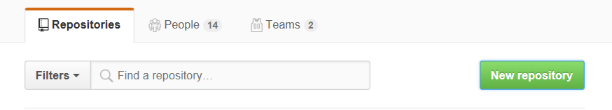

4. Add the repository name, description and select the repository as public or private, where

**PUBLIC**: Setting to public will make your repository area free to access to anyone with the URL.

**PRIVATE**: Setting to private will make your admin area protected by a login/password form

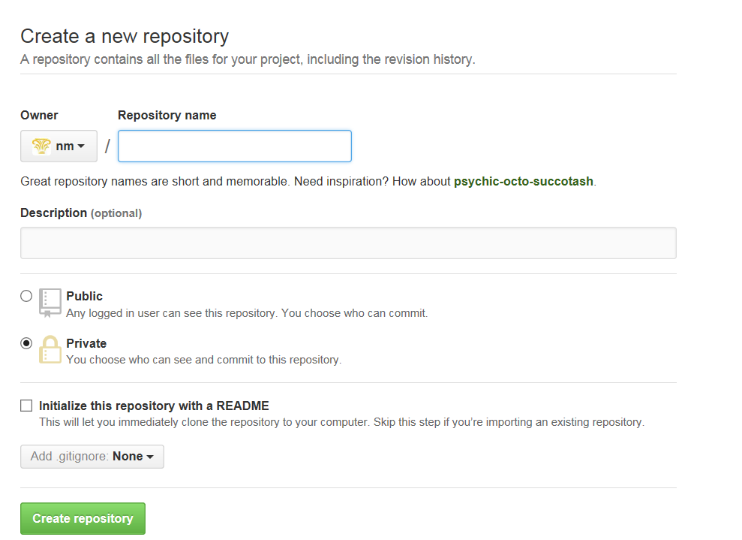

5. Under your organization name, click **teams add** the members to the team.



6. On the right side of the Teams tab, click **New team**.

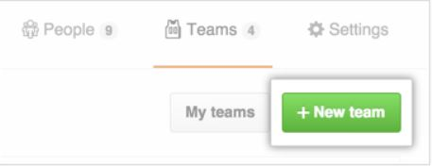

7. On the "Create new team" page, type the name for your new team.

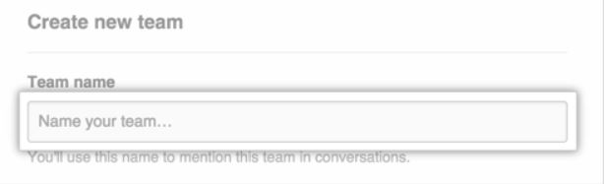

8. [Choose whether the team will be visible or secret](https://help.github.com/articles/creating-a-team/#team-visibility). You can [change this option later in the team settings](https://help.github.com/articles/changing-team-visibility).

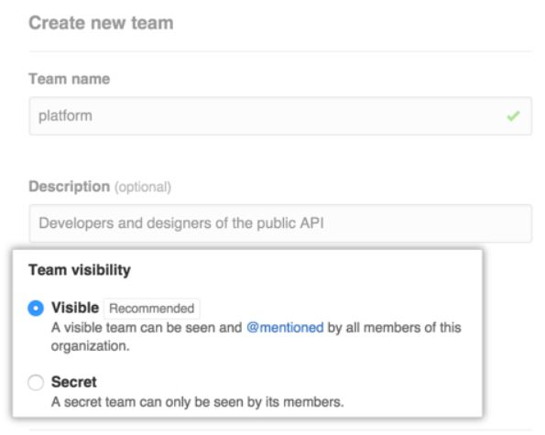

9. At the top of the list of team members, click **Repositories**.

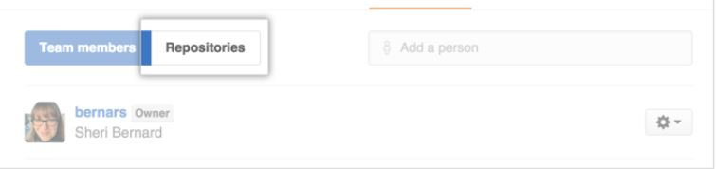

10. In the "Add repositories" field, type the name of a repository, then select it

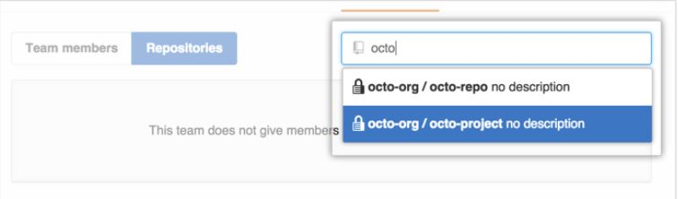

11. If necessary, [confirm your password](https://help.github.com/articles/sudo-mode).

12. Optionally, to the right of the repository name, choose a different [permission level](https://help.github.com/articles/repository-permission-levels-for-an-organization) for the team.

